Effects of decomposition, sampling depth, and body conditions on biomarkers for stress in blubber tissue from stranded whales

Valentina Melica¹, Shannon Atkinson¹, Jessica Huggins², Matthew Rogers³, Bryan Cormack³, Debbie Duffield⁴, Dalin D'Alessandro⁴ and John Calambokidis²

¹ University of Alaska Fairbanks, College of Fisheries and Ocean Sciences, Fisheries Department, Juneau, USA.
² Cascadia Research Collective, Olympia, USA.
³Alaska Fisheries Science Center, NOAA; Juneau, USA
⁴Portland State University, Biology Department, Portland, USA

TO DISCUSS:
We are including the following variable :
- Cortisol, Corticosterone
- Aldosterone
- Lipid %
In relation to:
- Blubber depth (1, 2, 3)
- COD ( 1,2)
- Body condition (1,2,3)
- Age and sex (1,2, 3)

ABSTRACT
Gray whales (Eschrichtius robustus) from the Eastern North Pacific Ocean experienced an unusual mortality event between 2019 and 2023, with unexpected high numbers of stranded individuals. Blubber from stranded whales is used for a variety of analyses that can help elucidate the physiological well-being of the individual, including the investigation of endocrine biomarkers and lipid content. However, cause of death sampling location and depth, as well as the body condition of the animal at the time of death can potentially affect the biochemistry of these compounds. The goal of this study was to investigate the variability in concentrations of 3 corticosteroid hormones and total lipid content using colorimetric assays across the full blubber depth of deceased gray whales. Specifically, total lipid, cortisol, corticosterone, and aldosterone concentrations were measured in blubber samples from 35 individuals stranded in Washington and Alaska between 2010 and 2019 and analyzed in relation to blubber depth, carcass decomposition and nutritional condition of the animal. Full-depth blubber was subsampled at three different distances from the skin: Surface (0-2 cm), Middle (3-6 cm), Bottom (> 6). Indices for Good, fair and poor body conditions were assigned by field responders and recovered from stranding reports. Overall, concentrations of all three hormones and total lipid (as a percent of mass analysed) were higher in the surface layer, but the difference was significant only for cortisol (p =0.05) and total lipid (p<0.05). Cortisol and corticosterone concentrations showed similar trends among cause of death with individuals that perished to trauma or nutritional stress having elevated concentrations. Aldosterone concentrations were lowest in individuals perished to trauma, and highest in individuals that died after a predation event. However, no statistical difference was detected for any of the three hormones. Body conditions appeared to affect each hormone differently. However, no significant differences were detected, Cortisol and aldosterone concentrations were affected by sex and age class, with immature females having significantly higher concentrations. Total lipid content and corticosterone were correlated (r=0.4), suggesting this hormone may play an important role in lipid metabolism. No significant difference were found in total lipid across body conditions, sex and age class. These findings further our understanding of using bioindicators for metabolic well-being in health assessments of large whales.

- Introduction
Gray whales occur exclusively in the Pacific Ocean (Rice et al., 1984) and two populations are recognized, Western (WNP) and Eastern North Pacific (ENP) populations, with overlapping feeding grounds in the eastern North Pacific (Mate et al., 2011). While the WNP population is still considered as critically endangered, the ENP population was removed from the U.S. endangered species list in 1994 and abundance estimates indicated the population has reached carrying capacity at 20,000 – 22,000 individuals (Swartz, 2018), and the most up-to-date estimate is approximately 27,000 individuals (Durban et al., 2017). The majority of ENP gray whales migrate annually between the lagoons of the Baja Peninsula, their breeding grounds, and the continental shelves of the Bering, Chukchi and -more recently- the Beaufort Seas to feed. An exception is the Pacific Coast Feeding Group (PCFG), a small group that forage primarily between southeastern Alaska and Northern California (Calambokidis et al., 2012). Migration and reproduction are tightly connected, as the migrating groups are staggered in time based on sex and reproductive states (Rice and Wolman, 1971; Swartz, 2018).
Gray whales are considered ecosystem sentinels (Moore 2008) since due to their feeding ecology and migratory patterns likely affected by changes in prey composition driven by climate or oceanographic perturbations. As their forage on lower trophic levels, primarily on benthic amphipods and decapods and are seasonally present in the Arctic, gray whales migration and is affected by the Pacific Decadal Oscillation, El Niño-La Niña oscillations, and sea ice (Moore et al., 2007, 2003; Perryman et al., 2002; Urbán et al., 2003). Along their migrating route, gray whales are exposed to a variety of anthropogenic sources of disturbance along their migration route, such as contaminants (Gulland et al., 2005; Krahn et al., 2001; Tilbury et al., 2002), underwater noise (Moore and Clarke, 2002), fishing operations and ship collisions (Baird et al., 2002; Douglas et al., 2008). Studies from the late 1980s reported avoidance and change in behavior due to noise disturbance comparable to drilling operations and air guns arrays (Malme et al., 1988; Moore and Clarke, 2002). Furthermore, given their foraging habit, gray whales are likely to ingest and accumulate chemical contaminants: even if no toxic concentrations have been reported in stomach content and blubber tissue of this species (Krahn et al., 2001; Varanasi et al., 1994; Hayes ). Even at low quantities organic contaminants may act as endocrine-disrupting chemicals, external compounds that can alter normal hormone function (Fossi and Marsili, 2003). Long-term effects of endocrine disrupting chemicals include reproductive failure, poor body conditions and adrenal gland damage (Godard-Codding and Collier, 2018). In 1999 – 2000, the ENP population of gray whales experienced an Unusual Mortality Event with more than 600 carcasses reported, with starvation as a contributing factor to mortality (Gulland et al., 2005). In 2019, more than 200 animals were found stranded across Mexico, United States and Canada and NOAA has issued a second UME (NOAA, 2020). While no common cause of death has been identified, many carcasses were in poor body conditions.
The speed and intensity of climate and oceanographic changes in marine ecosystems and the increased wildlife-human interactions warrant the need to search for biomarkers for assessing the physiological response to stress. Prolonged exposure and stimulation of an endocrine stress response may be detrimental to reproduction (Tilbrook et al., 2000; Wasser et al., 2017) and immune system function (Webster Marketon and Glaser, 2008), potentially leading to population decline (Wasser et al., 2017). Corticosteroids are involved in the physiological response to stress in terrestrial and aquatic mammals (Atkinson et al., 2015); however, there is a paucity of published research on physiological processes in large whales and specifically on stress-related endocrine profiles. Cortisol and corticosterone are secreted by the adrenal glands and are involved in maintaining metabolic homeostasis, including the stress response, with their main function being stimulation of gluconeogenesis to sustain the energetic requirements (Atkinson et al., 2015; Peckett et al., 2011; Tanaka et al., 2017). Aldosterone is another adrenal hormone and is primarily regulated by the rennin-angiotensin system. It mainly acts to regulate electrolyte balance, water retention and blood pressure (Kubzansky and Adler, 2010). When secreted excessively or over a prolonged period of time, these hormones can have detrimental effects on skeletal muscle and on the reproductive and cardiovascular systems.
Steroid hormones have been measured in a variety of tissues in multiple wildlife species. When available, blood serum, and feces are the matrices of choice for investigating endocrine response to very recent events (minutes to hours) (Atkinson et al., 2015, 1999; Burgess et al., 2017; Champagne et al., 2017; Hunt et al., 2006; Keogh and Atkinson, 2015; Robeck et al., 2017; Rolland et al., 2019, 2012, 2005; Steinman et al., 2016; Valenzuela-Molina et al., 2018), whereas for life-long endocrine profiles, steroid hormones have been extracted and measured in earplug and baleen plates (Hunt et al., 2018, 2017, 2014; Trumble et al., 2018, 2013). An increased number of studies have focused on blubber, as samples can be obtained with minimally invasive techniques and reflect close-to-recent physiological processes (Atkinson et al., 2019; Cates et al., 2020, 2019; Champagne et al., 2018; Kellar et al., 2015; Mingramm et al., 2020; Trana et al., 2015). Blubber is common to most marine mammals, and it consists of a vascularized layer of fat and connective tissue beneath the skin (Iverson and Koopman, 2019). Energy storage is the main function for this tissue; however, it also serves as a thermal insulator and aids buoyancy and hydrodynamics (Iverson and Koopman, 2019). Being a dynamic tissue, blubber changes in response to reproductive status, nutritional status, and age (Iverson and Koopman, 2019). Steroid hormones are synthesized from cholesterol and because of their lipophilic nature, blubber is a suitable tissue for endocrine analysis. Additionally, recent studies have shown that accumulation of steroids in this tissue occurs within hours from their secretion in blood (Champagne et al., 2018, 2017), suggesting that blubber can be used to describe recent physiological events.

LIPID CONTENT
IMPORTANCE OF STRANDED SAMPLES

Question
This study investigates corticosteroids and lipid content in blubber samples of stranded gray whales, to specifally:
  - Evaluate hormone concentrations in relation to blubber depth, body conditions and carcass decomposition
  - Compare hormone concentrations in stranded animals that perished of different cause of death
  - Compare hormone concentrations between healthy and stressed whales

- Methods
  - Individual Samples
Blubber samples from 35 (22 females and 13 males) gray whale carcasses were obtained through the United States Marine Mammal MHSRP. These samples came from whales that were found and examined between 2010 and 2019, along the coasts of Washington (n= 28) and Alaska (n=7). Out of 35 individuals, 19 were part of the 2019 UME. Information on the animal (sex, reproductive state, age class and body condition) as well as likely cause of death (COD), body condition and carcass condition were obtained from the MMHSRP Level A forms and necropsy reports.
Specifically, each animal was assigned to a category of body condition that ranged from Excellent to Poor, carcass conditions were rated on a scale of 2 to 4, with 0.5 increment, where 2 indicates a fresh carcass, and 4 indicates a highly decomposed body. The cause of death (COD) was determined as: trauma (n= 10), when signs of accidents were present on the carcass, including collision with vessels, nutritional stress (n= 4), when the animal was found severely emaciated, entanglement (n= 2), when found entangled in fishing line (one of the animals was a live stranding) or predation (n= 4), when the animal was killed by predators. Two of the latter whales were killed by killer whales and one was harvested illegally. All but one of the carcasses from 2019 were and counted as part of the UME and found in poor body condition (n= 15).

  - Hormone extractions, validation and measurement
Full blubber depth samples were subsampled at their storage location (e.g., NMFS SWFSC, UAS, CRC) and transferred to the University of Alaska Fairbanks facility in Juneau AK, where they were stored at -80°C until further processing. Blubber depth ranged between 6 to 12 cm in length. Each sample was subsampled along three depth categories: “Surface” from skin to 2 cm depth, “medium” from 3 to 6 cm, and “bottom” from > 6 cm blubber depth . Subsamples mass ranged between 0.096 and 1.27 g (mean ± standard deviation= 0.23 ± 0.18 g) for gray whales. Hormone extraction was performed following the step-wise process described in Atkinson et al. (2019) adapted from Kellar et al., (2006) and Mansour et al., (2002). Briefly, samples were first macerated manually using a Teflon tip homogenizer in 1 ml of ethanol, then extracted using a series of solvent-supernatant transfers, with multiple organic solvents (ethanol, acetone, ether, acetonitrile and hexane). Extracts were diluted in 1 ml of methanol before being aliquoted for each assay, dried under forced air and rehydrated with assay buffer. Hormone concentrations were measured using EIA kits from Arbor Assay (Ann Harbor, MI) for cortisol (Kit # K003), corticosterone (Kit # K014) and aldosterone (Kit # K052), following the manufacturer’s protocols. Assays for cortisol and corticosterone were previously validated for gray whale blubber (Melica et al. 2022). Analytical (parallelism and accuracy test) and biological validations for cortisol and corticosterone are reported in Melica et al. (2022), validation of aldosterone is presented below. For each sample, hormones measurements (in pg/ml) were corrected for dilution factor and extracted blubber mass, and expressed as ng/g. The intra-assay percentage coefficient of variation (CV) was <10%, for all hormones. If any sample had a CV >10%, it was re-diluted accordingly and re-assayed. Inter-assay validation was determined using two internal controls for each hormone. For the corticosterone assay, the CVs (%) of the internal controls used were 16.9% and 10.9%; for cortisol, 12.2% and 15.6%; for aldosterone, 11.5% and 11.2%.

    - Validation of aldosterone EIA for gray whale blubber

Analytical validation for aldosterone was performed testing pools of extract from males (n=8) and females (n=8) for parallelism and accuracy. To test for parallelism, each pool was serially diluted (1:1, 1:2, 1:4, 1:8, 1:16 and 1:32) and tested for parallel displacement with the standard curve. This step is used to confirm that the assay antibody can reliably bind the antigen throughout the range of the standard curve. It also indicates at what dilution hormone concentration shows to 50% binding. Parallelism was assessed both visually and using a t-test to determine statistical differences in slopes, with lack of significance supporting parallelism. The accuracy test is used to determine if any other compounds in the extracts are interfering with the antigen-antibody binding of the assay, testing how well the measured concentrations corresponded to added concentrations of each hormone. For this step, an equal volume of each pool was spiked with each standard, the recovered mass was graphed against the added mass and it was tested for linearity. Linearity is met when a linear slope close to 1.0 (acceptable range: 0.7 – 1.3) is achieved (Hunt et al., 2017b). Samples were run in duplicate, at dilutions displacing around the 50% binding based on parallelism test.

Biological validation for aldosterone. In burgess et al. fecal aldosterone showed generally elevated concentrations in adult males and pregnant females. Because our dataset did not include any pregnant or potentially lactating females, biological validation for aldosterone was carried our comparing concentrations concentrations between mature and immature individuals.
  - Lipid extraction and measurement
TBD
  - Statistical Analysis
    - Analysis of hormone concentrations across blubber depth.
The final datasets consisted of 19 individuals for cortisol, of which 17 had values across all three blubber depths; 16 individuals for corticosterone with values of all blubber depths; 12 individuals for aldosterone, with 10 with values across all three categories of blubber depth. Exploratory data analysis indicated that hormone concentrations did not meet the requirement for parametric test. Additionally, person correlation test indicated corticosterone to be positive correlated with cortisol (r = 0.49) and aldosterone (r= 0.65).
To determine the effect of blubber depth on hormone concentrations and lipid content, generalized mixed effects models (function lmer in package lme4 CIT) were developed with blubber depth as fixed factors and whale ID as a random factor. The model was then compared to the null model using the Akaike Index Criterion for small sample size (AICc). The model with the lowest AICc was considered the best option. A post-hoc test comparing Estimated marginalized means (EMM) was applied to determine if there was any statistical difference in hormones concentrations and lipid content across blubber depth (emmeans).
All statistical and graphical analyses were conducted using the software R v.3.5.2 (R Core Team, 2020).

    - Analysis of hormone concentrations in relation to cause of death.
Cortisol concentrations were detected in 34 samples, of these two were identified as outliers with concentrations higher than 20 ng/g. Because hormone concentrations in relation to COD did not meet normality requirements (using Shapiro Wilk test on residuals), a non-parametric test for analysis of variance (Kruskall-Wallis) was used to test for significant differences. For cortisol two outliers with concentrations > 20 ng/g were identified. Test was performed with and without outliers. For both corticosterone and aldosterone datasets, one outlier for each hormone was identified and removed from the analysis.

    - Analysis of hormone concentrations and lipid content in relation to body condition
For this analysis, only individuals with body conditions listed as GOOD, FAIR and POOR were compared. Outliers for corticosterone and aldosterone were also removed from the data. Because hormone concentrations in relation to COD did not meet normality requirements (using Shapiro Wilk test on residuals), a non-parametric test for analysis of variance (Kruskall-Wallis) was used to test for significant differences.

    - Analysis of hormone concentrations and lipid content in relation to age class and sex
For this analysis, the dataset was filtered to include individuals of known age class and sex. Age class was determined at the time of necropsy based on length. Generalized linear model were fitted to hormone concentrations in relation to age class, sex and the interaction of both. The models were then compared among them and to the null model using the Akaike Index Criterion for small sample size (AICc). The model with the lowest AICc was considered the best option. A post-hoc test comparing Estimated marginalized means (EMM) was applied to determine if there was any statistical difference in hormones concentrations and lipid content across blubber depth (emmeans).

- Results
  - Validation of Aldosterone
Parallel displacement to the standard curve of the serial dilutions from the male and female pools were confirmed visually and statistically for both species and sexes (p >0.05) (Table 3.2; Fig. 3.1C); for the accuracy check the standard mass recovered showed linear relationships with the mass added for both species and sexes, with slopes ranging from 1.0 to 1.3 (Table 3.2). The serial dilutions from the blue whale blubber exhibited 50% binding at 1:1 and 2:1, for female and male pools respectively, while those from the gray whale blubber showed 50% binding at 1:1 and 4:1, for females and males respectively. Biological validation

  - Analysis of hormone concentrations across blubber depth.

Table 1: Summary of hormone concentrations and lipid content in each layer of blubber.
Blubber Depth | Sex | Cortisol ng/g |  |  | Corticosterone ng/g |  |  | Aldosterone ng/g |  |  | Lipid content %
 |  | mean | standard deviation | range | mean | standard deviation | range | mean | standard deviation | range | mean | standard deviation | range
Surface | F | 11.33 | 14.24 | 43.80 | 1.48 | 1.20 | 3.01 | 0.34 | 0.53 | 1.47 | 14.53 | 11.01 | 34.11
Medium | F | 4.83 | 6.22 | 16.83 | 0.76 | 0.47 | 1.24 | 0.05 | 0.03 | 0.09 | 0.93 | 0.66 | 1.48
Bottom | F | 8.58 | 9.11 | 27.63 | 0.71 | 0.62 | 1.68 | 0.05 | 0.04 | 0.10 | 0.24 | 0.27 | 0.67
Surface | M | 3.89 | 4.06 | 9.75 | 0.56 | 0.63 | 1.92 | 0.07 | 0.04 | 0.09 | 23.63 | 24.83 | 58.31
Medium | M | 2.95 | 3.58 | 10.44 | 0.79 | 0.69 | 1.72 | 0.07 | 0.11 | 0.25 | 3.65 | 3.19 | 7.76
Bottom | M | 3.06 | 3.70 | 10.45 | 0.59 | 0.37 | 1.03 | 0.11 | 0.21 | 0.43 | 12.81 | 16.08 | 34.02

Based on AICc, the model including blubber depth as predictor was identified as the better when compared to the null model for cortisol concentrations. The post hoc test found significant difference in cortisol concentrations between the Surface and Medium blubber layers (EMMeans t (34.2) = 2.5, p = 0.05). When three outliers (cortisol > 25 ng/g) were removed, the difference was no longer significant.
For corticosterone, the null model was had a lower AICc (116.7) when compared to the model with Blubber death as predictor (AICc=120.6). Results did not change when three outliers were removed. Similarly, the null model was the best model for aldosterone concentrations (AICc= 17.5) when compared to the model with Blubber depth (AICc=25.2). Results did not change when one outlier was removed.
For lipid content, the model with blubber depth was found to be the best model (AICc= 278.3). Based on the post hoc test results the lipid content in the surface layer is significantly different from those in the medium (EMMeans t(19.1) = 3.4 , p= 0.01) and bottom (t(19.8) = 3.3, p= 0.01) layers. Two samples were identified as outliers as both had lipid content > 50% . When removed, the lipid content in the surface was significantly different from that in the medium layer (t(18.2)= 2.8, p= 0.03), but not the bottom layer, 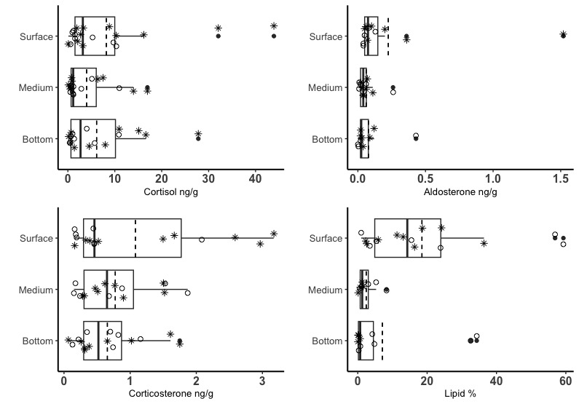
Figure 2: Hormone concentrations(ng/g) and lipid content (%) along blubber depth in samples from stranded female (*) and male (°) gray whales.

  - Analysis of hormone concentrations in relation to cause of death.
When including outliers, mean (± standard deviation) cortisol concentrations were 12.80 (±12.87) ng/g for samples in the Trauma category, followed by 6.31 (±8.00) ng/g and 5.57 (±4.18) ng/g for samples in the Nutritional stress categories (UME and not), and 3.8 (±3.68) and 2.0 (±0.95) ng/g for samples in the Entanglement and Predation categories (Fig. 3a). However, there was no significant difference. Analytical results did not change when two outliers, both with mean cortisol > 20 ng/g, were removed.
From the dataset for corticosterone, one obvious outlier was removed. Mean (± standard deviation) concentrations were 1.06 (± 1.18) ng/g for samples in the Trauma category, 3.82 (± 3.17) ng/g, 1.26 (± 1.44) ng/g for samples in the Nutritional stress categories (UME and not), and 1.77 (± 1.74) and 0.59 (± 0.65) ng/g for samples in the Entanglement and Predation categories (Fig. 3b). However, there was no significant difference (Kruskal-Wallis: chi-squared = 6.72, df = 4, p-value = 0.15).
Similarly for aldosterone, one obvious outlier was removed from the analysis. Mean (± standard deviation) aldosterone concentrations were 0.27 (± 0.25) ng/g for samples in the Trauma category, followed by 0.35 (± 0.66) ng/g and 0.25 (± 0.18) ng/g for samples in the Nutritional stress categories (UME and not), and 0.33 (± 0.26) and 0.39 (± 0.39) ng/g for samples in the Entanglement and Predation categories (Fig. 3c). However, there was no significant difference (Kruskal-Wallis: chi-squared = 2.03, df = 4, p-value = 0.73).
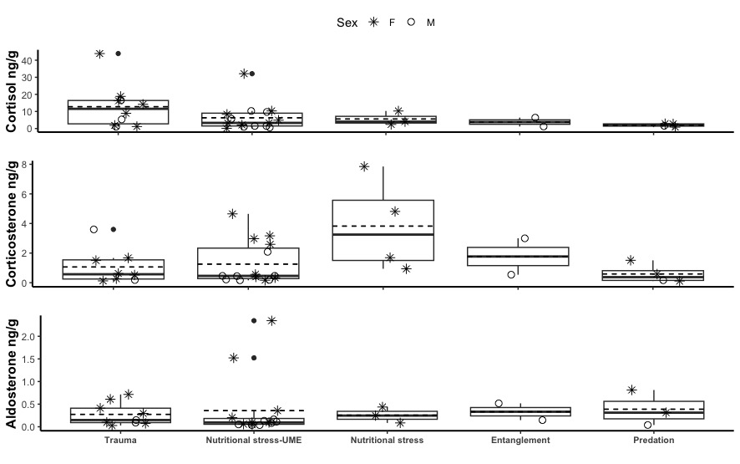
Figure 3: hormone concentrations across cause of death

  - Analysis of hormone concentrations and lipid content in relation to body condition
Mean cortisol concentration was the lowest in samples with Fair body conditions (mean ± sd = 3.79 ± 2.57 ng/g, n= 7), but it was not statistically significant from that from samples with Good (13.0 ± 16.6 ng/g, n= 6 ) and Poor (7.8 ± 8.7 ng/g, n= 16) body conditions (Kruskal-Wallis chi-squared = 0.7, df = 2, p-value = 0.7). Mean corticosterone concentration was elevated in samples with Poor body condition ( 2.11 ± 2.24 ng/g, n= 14), but it was not statistically significant from that from samples with Good (0.8 ± 0.6 ng/g, n= 6 ) and Fair (0.6 ± 0.7 ng/g, n= 7) body conditions (Kruskal-Wallis chi-squared = 0.9, df = 2, p-value = 0.6).
Mean aldosterone concentration was lowest in samples with Fair body condition ( 0.2 ± 0.09 ng/g, n= 7), but it was not statistically significant from that from samples with Good (0.4 ± 0.3 ng/g, n= 6 ) and Poor (0.4 ± 0.7 ng/g, n= 14) body conditions (Kruskal-Wallis chi-squared = 0.8, df = 2, p-value = 0.6, Fig 4).
No significantly difference was found in lipid content among body conditions (Kruskal-Wallis chi-squared = 4.1, df = 2, p-value = 0.13).

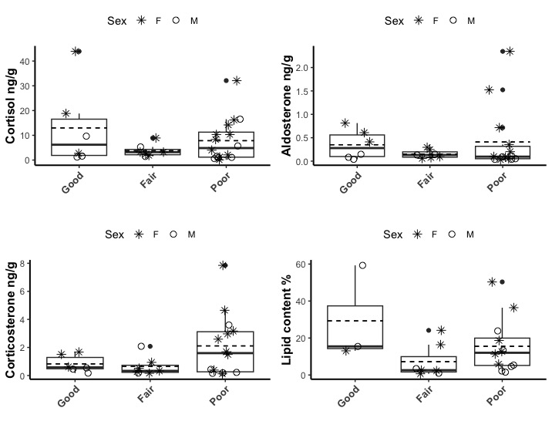
Figure 4: Hormone concentrations and lipid content in relation to body conditions

  - Analysis of hormone concentrations and lipid content in relation to age class and sex

The model including the interaction of sex and age class as predictors was found as the best model to explain cortisol concentrations (AICc= 233.23). Mean (± sd) cortisol concentrations were significantly elevated in immature females (17.3 ± 14.5 ng/g, n=8) compared to adult females (4.6 ± 3.6 ng/g, n=11) whales. However, this difference was driven by the two outliers with concentrations higher than 30 ng/g, both measured in immature females. When those were removed, the model including age class became the best model (lowest AICs) and a weak statistically significant difference was found in cortisol concentrations between immature and adult individuals (EMMeans t(28)= -2.1, p= 0.05).

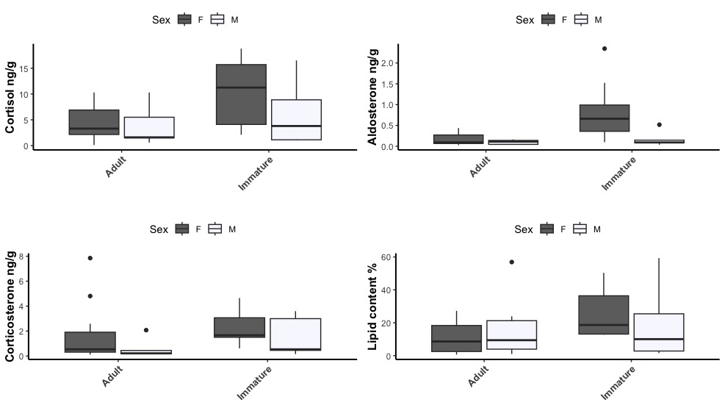
Figure 5: hormone concentrations and lipid content in relation to age class
For corticosterone, one outlier with concentration > 20 ng/g was identified from an immature female. Based on AICc, the model with Age class as explanatory variable was identified as the best model (AICc=182.3). Mean corticosterone was 3.5 ± 5.6 ng/g in Immature individuals (n=13) and 1.3 ± 2.0 ng/g in adults (n=19). However, the difference was not statistically significant (p=0.11). When the outlier was removed the model including Sex as explanatory variable was identified as the best model (AICc= 128.3). Mean corticosterone concentrations were elevated in females (1.9 ± 2.1 ng/g, n=19) than in males ((1.0 ± 1.2 ng/g, n=12) but this difference was not statistically significant ((EMMeans t(29)= 1.5, p= 0.15).
For aldosterone, one outlier with concentration > 10 ng/g was identified from an adult female. Based on AICc, the model including Age class as explanatory variable was identified as the best model (AICc=42.31). Mean aldosterone concentrations were elevated significantly higher in whales categorized as adult (0.9 ± 3.3 ng/g, n=19) than immature (0.6 ± 0.7 ng/g, n=13; EMMeans t(29)= -2.8, p= 0.01). When the outlier was removed, the best model became the one including the interaction of Age class and Sex as explanatory variable (AICc= 39.2). Aldosterone concentrations were significantly different between immature and adult females (p= 0.01), and between immature females and immature and adult males (p= 0.03 and 0.01 respectively, Fig.5). Age class was found as a predictor also for lipid content, but the difference was not significant between Immature and Adult whales (p=0.2).

